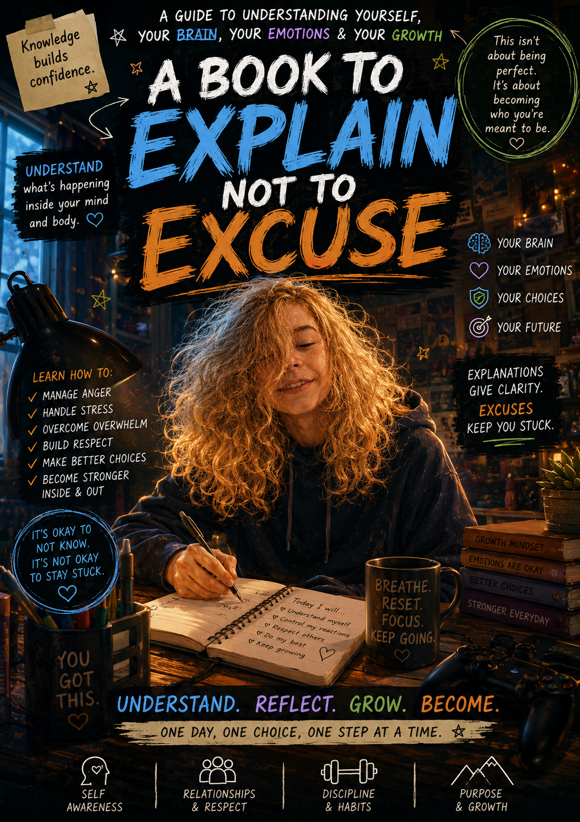

💛 INTRODUCTION
Growing up can feel confusing sometimes.
One minute you may feel fine…
and the next you feel angry, overwhelmed, emotional, irritated, embarrassed, or like nobody understands you.
You may notice yourself changing.
Your thoughts changing.
Your reactions changing.
Your interests changing.
And sometimes, without understanding what is happening inside you, those feelings can become frustrating, overwhelming, or difficult to explain.
This workbook was created to help with that.
Not to shame boys.
Not to label boys as “bad.”
And not to excuse harmful behaviour either.
But to help explain what may be happening inside your brain, body, emotions, nervous system, and identity during puberty and growing up.
Because understanding yourself matters.
Inside this workbook you will learn about:
- brain development
- hormones and testosterone
- emotions and overwhelm.
- anger and reactions.
- dopamine and gaming
- embarrassment and confidence
- communication and empathy
- emotional regulation
- healthy masculinity
- accountability and growth
You will also find:
📖 relatable stories
🧠 reflection activities
☑️ quizzes and check-ins
✍️ journaling pages
💥 real-life scenarios.
This workbook is here to remind you of something important:
Feelings are real.
Emotions are human.
Making mistakes is part of growing.
But your choices still matter too.
You are not expected to be perfect.
You are learning.
You are growing.
And understanding yourself is one of the strongest things you can do.
— InnerWonderland 💛

🧠⚡ BRAIN UNDER CONSTRUCTION
A Book to Explain, Not to Excuse
Understanding Puberty, Emotions, Reactions & Becoming a Good Man
A Self-Understanding Workbook for Boys Aged 10–14
By InnerWonderland
INDEX
- Welcome
- Your Brain Under Construction
- Hormones & Testosterone
- Sleep, Testosterone & Mood
- Body Changes, Hygiene & Self-Care
- Attraction, Crushes & Big Feelings
- Why Embarrassment Feels So Big
- Why Am I More Irritated?
- Gaming, Dopamine & Overload
- Independence & Wanting Space
- Understanding Anger
- Respect, Tone & Communication
- Understanding Girls, Sisters & Other People
- What Makes a Good Man?
- Emotions & Anger Journaling
- Regulation Tools & Emotional Skills
- Quiz Time
- Reflection & Self Check-In

WELCOME
🌱 Growing Up Changes You — And That Is Not a Bad Thing

During puberty, your body, emotions, thoughts, identity, and brain begin changing.
Sometimes this can feel strange.
You may start noticing:
Bigger emotions
Different thoughts
New interests
Mood changes
More irritation
Wanting more space
Feeling confused about yourself
Feeling emotional but not knowing why
Wanting independence
Feeling overwhelmed more easily
Sometimes boys quietly wonder:
“Am I becoming a bad person?”
“Why am I reacting like this?”
“Why do I suddenly feel different?”
“Why do I want to be alone more?”
“Why do I feel angry or emotional so quickly?”
The truth is:
You are not going crazy.
You are growing.
And when we do not understand what is happening inside us, we can:
Feel shame.
Hide emotions.
Retreat from others
Lash out.
Become rude.
Shut down
Feel guilty afterward.
Sometimes there can be BIG feelings happening inside, but we do not yet have the words to explain them.
That is one reason this workbook exists.
To help you understand yourself better.
Because understanding yourself helps you:
Feel less confused.
Feel less alone.
Recognise overwhelm earlier.
Handle emotions better.
Communicate more clearly.
And grow into a strong, respectful person.

📖 SHORT STORY – “Why Am I So Angry?”

Jay sat staring at his monitor after snapping at his sister again.
He did not even fully know why he reacted so strongly.
All she had done was ask him a question.
But lately everything felt louder.
More irritating.
His thoughts felt crowded.
His body felt restless.
Sometimes he wanted everyone around him.
Other times he wanted everyone to disappear.
He felt guilty afterward.
But also annoyed.
And confused.
One moment he felt older.
The next moment he felt like a little kid again.
He rubbed his face and thought:
“What is wrong with me lately?”
The truth?
Nothing was “wrong” with him.
His brain, emotions, hormones, identity, and nervous system were all changing at once.
What mattered now was learning how to understand himself and handle those changes in healthy ways.

🧠 YOUR BRAIN UNDER CONSTRUCTION

Your brain changes massively during puberty.
Imagine your brain like a game downloading a giant update.
Some systems are improving.
Some systems are still loading.
Some systems are glitching.
During puberty:
Emotional parts of the brain become stronger.
Reaction systems become faster.
Impulse control is still developing.
Planning and decision-making are still growing.
Your need for independence increases
This means sometimes:
😤 You react before thinking
🔥 Small things feel BIG
🚪 You want people to leave you alone
💥 You may snap or become rude quickly
🧠 Your thoughts may feel louder or more intense
The important thing is learning to NOTICE what is happening inside you.
That is real strength.

QUICK CHECK-IN

Circle what you relate to:
😤 Irritated easily
🎮 Wanting to stay in your own world
🚪 Wanting more independence
😵 Feeling overwhelmed
💥 Bigger reactions lately
😑 Feeling misunderstood
🧠 Overthinking
😴 Tiredness
❤️ Wanting people to understand you

⚡ HORMONES & TESTOSTERONE
Hormones are chemical messengers in the body.
During puberty, testosterone increases a lot in boys.
This can affect:
Mood
Emotions
Motivation
Energy
Attraction
Confidence
Irritation
Restlessness
Anger
Sleep
Reactions
Sometimes boys feel:
😤 More annoyed
🔥 More intense
😑 Defensive
😵 Overwhelmed
🚪 Wanting space
🎮 Drawn to stimulation and games
😴 More tired than usual
This is NORMAL.
But remember:
Feeling something is not the same as acting on it.
You are still responsible for:
Respect
Communication
Apologising
Repairing mistakes
Learning emotional control

MULTIPLE CHOICE
Testosterone can affect:
Emotions
Mood
Energy and reactions
All of the above

Puberty means:
You are becoming a bad person.
Your brain and body are changing rapidly.
You can treat people however you want.

😴 SLEEP, TESTOSTERONE & MOOD

During puberty, your body and brain need MUCH more rest.
Even if you do not always realise it.
A lack of sleep can affect:
Mood
Reactions
Irritation
Anger
Focus
Motivation
Anxiety
Emotional control
Sometimes when boys are exhausted, they may:
😤 Snap more easily
😑 Feel emotionally flat
🧠 Struggle to think clearly
🔥 React more intensely
🎮 Want more dopamine and stimulation
😴 Feel tired but unable to switch off

Sleep is not “lazy.”
Sleep is part of brain development.
Your brain and body are doing huge amounts of work during puberty.

📖 SHORT STORY – “The Late Night”

Owen stayed online far too late.
The next morning everything annoyed him.
His little sister talking.
The brightness outside.
Even his favourite game felt frustrating.
By the afternoon he exploded over something tiny.
Later that evening his mum asked him:
“How much sleep did you actually get?”
That was when he realised:
Sometimes exhaustion disguises itself as anger.

QUICK THINKING
What happens to YOU when you are overtired?
☐ I get irritated faster
☐ I feel emotional
☐ I shut down
☐ I become rude more easily
☐ I struggle to focus
☐ I feel overwhelmed faster

🧼 BODY CHANGES, HYGIENE & SELF-CARE

Puberty also changes your body.
This can feel awkward, embarrassing, exciting, confusing — or all of them at once.
You may notice:
Body odour changing
More sweating
Skin changes or acne
Voice changes
Hair growth
Growth spurts
Bigger appetite
Increased tiredness
This is NORMAL.
Hygiene is not about being “perfect.”
It is about caring for yourself and your body.
Things that help:
✅ Showering regularly
✅ Deodorant
✅ Clean clothes
✅ Brushing teeth
✅ Washing your face
✅ Drinking water
✅ Sleep
✅ Healthy food
Looking after yourself can actually help confidence and mood too.

📖 SHORT STORY – “The Hoodie”
Max kept wearing the same hoodie every day.
Eventually he started feeling uncomfortable and self-conscious.
One morning he finally showered properly, changed his clothes, brushed his hair, and cleaned his room.
Strangely, he noticed something:
He felt lighter afterward.
Sometimes small acts of self-care help the brain feel calmer too.

❤️ ATTRACTION, CRUSHES & BIG FEELINGS

During puberty, emotions and attraction can suddenly feel MUCH stronger.
You may:
Notice people differently.
Develop crushes.
Feel nervous around someone.
Overthink interactions.
Feel embarrassed easily.
Want approval or attention.
Feel confused by emotions.
This is normal too.
Sometimes crushes can feel HUGE because your emotions and hormones are becoming stronger during this stage of life.
That does not make you weak.
It makes you human.

📖 SHORT STORY – “Why Am I Nervous
”
Every time Ava spoke to him, Ben suddenly forgot how to act normal.
His brain felt scrambled.
His face felt hot.
Later he kept replaying every conversation in his head.
At first, he thought something was wrong with him.
But actually, his brain and emotions were simply developing in new ways.

😳 WHY EMBARRASSMENT FEELS SO BIG

One of the strongest feelings during puberty can actually be embarrassment.
Boys this age often become VERY aware of:
What people think of them?
Looking silly
Making mistakes
Being judged
Sounding emotional
Being laughed at
Rejection
That is one reason some boys:
Become defensive.
Joke constantly
Act rude.
Shut down emotionally
Avoid vulnerability.
Pretend not to care.
Sometimes it is protection.
Not because they are bad.
But because embarrassment can feel incredibly intense during puberty.

IMPORTANT TRUTH

Making mistakes is part of growing.
Feeling embarrassed is part of being human.
You do not need to become cold or unkind to protect yourself.
Real confidence grows through:
Self-awareness
Kindness
Humour
Accountability
And learning to handle uncomfortable feelings without hurting others 💛

😤 WHY AM I MORE IRRITATED?
📖 SHORT STORY – “The Build Up”

Ethan had already had a long day.
He did not sleep well.
His game kept lagging.
The house felt noisy.
He felt hungry.
His brain already felt overloaded.
Then his sister accidentally knocked his drink.
Suddenly he exploded.
“FOR GOD SAKE! LEAVE ME ALONE!”
Everyone went quiet.
A few minutes later, Ethan sat in his room feeling guilty.
The reaction felt too big.
But in the moment, it felt impossible to stop.
What Ethan did not realise was that his nervous system had been building stress all day.
The drink was not the real reason.
It was the final drop in an already full bucket.
Learning to notice stress BEFORE exploding is one of the most important emotional skills a person can develop.
When your nervous system becomes overloaded, irritation increases.
Things that can overload the brain:
Too much gaming
Loud environments
Stress
Arguments
Lack of sleep
Too much pressure
Constant stimulation
Feeling misunderstood
Hunger
Big emotions
When overloaded, people often:
💥 Snap at others
😑 Become rude
🚪 Shut people out
😤 Push people away
🧠 Struggle to think clearly
Sometimes what looks like “attitude” is actually overwhelmed.
But again — overwhelm is still not permission to hurt others.

RELATABLE SCENARIO

You are gaming.
You are focused.
Someone interrupts you several times.
You already feel overwhelmed.
You suddenly snap:
“LEAVE ME ALONE!”
Afterward, you feel calmer and realise you were too harsh.
Questions:
What may have caused the reaction?
Was the feeling real?
Was the reaction still hurtful?
What could be done differently next time?

🎮 GAMING, DOPAMINE & OVERLOAD
Games are designed to stimulate the brain.
When gaming, the brain releases dopamine.
Dopamine is connected to:
Motivation
Excitement
Reward
Focus
Fast stimulation
This is not bad.
But too much stimulation without balance can make real life feel:
😑 Boring
😤 Irritating
🧠 Mentally tiring
💥 Easier to react in
That is why balance matters.
Not because games are evil.
But because your brain needs:
Movement
Sunlight
Sleep
Offline time
Real conversations
Rest
Quiet
Nature
Physical activity

QUICK THINKING

What things help YOUR brain feel calmer?
☐ Gaming breaks
☐ Fresh air
☐ Sleep
☐ Music
☐ Quiet time
☐ Food and water
☐ Exercise
☐ Talking to someone
☐ Time alone
☐ Less noise

🚪 INDEPENDENCE & WANTING SPACE

One of the biggest parts of growing up is wanting more independence.
This is normal.
You may:
Want more privacy.
Want more control.
Want to make your own choices.
Want people to stop treating you like a little kid.
Want time alone.
That does NOT mean you stop needing:
Guidance
Boundaries
Love
Support
Family
Growing up means learning freedom AND responsibility together.

📖 SHORT STORY – “Leave Me Alone”.
Kai shut his bedroom door hard.
“I JUST WANT SOME SPACE!”
A few minutes later he sat on his bed feeling confused.
Part of him wanted everyone to leave him alone.
Another part of him actually wanted someone to understand him.
That is something many teenagers experience.
Wanting independence does not mean you stop needing care, connection, support, or guidance.
It simply means your identity is growing.

REFLECTION
What helps you feel respected and understood?
What boundaries help you feel calmer?

😤 UNDERSTANDING ANGER
Anger itself is not bad.
Every human being feels anger sometimes.
Anger is often a signal.
Sometimes underneath anger there may actually be:
Overwhelm
Embarrassment
Shame
Frustration
Sadness
Feeling powerless
Exhaustion
Feeling misunderstood
Stress
Hurt
But because anger feels stronger and easier to express, it often comes out first.
The important thing is learning:
✨ Anger is a feeling.
✨ Behaviour is a choice.
You are allowed to FEEL angry.
You are NOT allowed to:
❌ insult people
❌ threaten people
❌ scare people
❌ constantly belittle others
❌ damage things
❌ use anger to control people
Strong people learn how to:
✅ pause
✅ breathe
✅ communicate
✅ walk away when overwhelmed
✅ repair after mistakes

📖 SHORT STORY – “The Controller”

Noah lost the game.
Again.
His chest felt hot.
His jaw tightened.
He wanted to throw the controller across the room.
For a second he imagined smashing it.
But then he stopped.
He stood up.
Walked to the kitchen.
Drank some water.
Took a breath.
Ten minutes later he realised:
The feeling had passed.
That is something important to understand about emotions.
Feelings move.
They rise.
They peak.
Then they calm again.
You do not have to act on every feeling immediately.
That is emotional strength.

QUICK SELF CHECK

When I feel angry I sometimes:
☐ Shout
☐ Shut down
☐ Ignore people
☐ Get sarcastic
☐ Feel overwhelmed
☐ Want space
☐ Say things I regret later
☐ Feel guilty afterward

WHAT HELPS ME CALM DOWN?

☐ Walking away
☐ Water
☐ Music
☐ Gaming break
☐ Exercise
☐ Quiet
☐ Talking
☐ Deep breaths
☐ Fresh air
☐ Writing things down

🗣️ RESPECT, TONE & COMMUNICATION
Sometimes people think:
“I didn’t mean it, so it shouldn’t matter.”
But tone matters.
Words matter.
The way we speak to people affects them.
Examples:
❌ “You’re so annoying.”
✅ “I feel overwhelmed and need space.”
❌ Ignoring everyone and snapping
✅ Asking for a break calmly
❌ Belittling siblings
✅ Communicating frustration respectfully
Respect is not weakness.
It is emotional strength.

📖 SHORT STORY – “I Didn’t Mean It”.

Luca rolled his eyes at his sister and muttered:
“You’re so dramatic.”
Later that night he overheard her crying in her room.
Suddenly the words felt different.
He realised something important:
Even if we are frustrated, our words still affect people.
Sometimes impact matters more than intention.

MULTIPLE CHOICE
Which response shows emotional strength?
Mocking someone
Insulting people when angry
Communicating respectfully even when frustrated

❤️ UNDERSTANDING GIRLS, SISTERS & OTHER PEOPLE
Everyone has feelings.
Sometimes when people are overwhelmed, they forget that their words affect others.
But strong people learn empathy.
Empathy means:
Thinking about how others feel
Understanding impact
Learning repair
Recognising when someone is hurt.
Being emotional does not make someone weak.
Crying does not make someone weak.
Talking kindly does not make someone weak.
Real strength includes kindness.

📖 SHORT STORY – “I Was Only Joking”.

Luca laughed after making fun of his sister.
To him it felt funny.
But later he noticed she had gone quiet.
At first, he thought:
“She’s overreacting.”
But then he stopped and thought about it.
What feels small to one person can feel big to someone else.
Sometimes people hide hurt feelings instead of talking about them.
That does not mean the hurt is not real.
Learning empathy means learning to think beyond only your own feelings in the moment.

THINK ABOUT IT
How would YOU want someone to speak to you when you feel overwhelmed?

🌱 WHAT MAKES A GOOD MAN?
📖 SHORT STORY – “The Difference”

Two boys were both angry.
One used his anger to insult, control, and hurt people.
The other still felt angry — but he learned how to pause, apologise, reflect, and grow.
Neither boy was perfect.
But one chose accountability.
That choice changes the kind of man someone becomes.
A good man is NOT someone who:
❌ never feels angry
❌ never struggles
❌ pretends to have no emotions
❌ dominates others
❌ acts cold to seem strong
A good man:
✅ Learns from mistakes
✅ Takes accountability
✅ Protects people instead of hurting them
✅ Learns emotional control
✅ Respects others
✅ Repairs harm
✅ Keeps growing
✅ Is honest
✅ Can apologise
Good men are built over time.

MYTH VS FACT

Myth:
“Being rude and emotionless makes boys stronger.”
Fact:
Real strength is self-awareness, respect, emotional control, honesty, and accountability.

WHAT KIND OF MAN DO YOU WANT TO BECOME?

☐ Respectful
☐ Honest
☐ Strong
☐ Kind
☐ Calm under pressure
☐ Protective
☐ Disciplined
☐ Emotionally aware
☐ Responsible
☐ Trustworthy

📓 EMOTIONS & ANGER JOURNALING
Why Keeping a Journal Can Actually Help
A lot of boys keep everything inside.
Sometimes there are BIG feelings happening internally, but no clear way to explain them.
That pressure can build up.
And when pressure builds up, it can come out as:
Anger
Shutting down
Irritability
Rudeness
Exploding suddenly
Feeling emotionally overloaded
Feeling confused
Journaling is NOT about being weak.
It is actually a tool that helps:
✅ clear the brain
✅ understand emotions
✅ notice patterns
✅ release stress
✅ process overwhelm
✅ understand triggers
✅ calm the nervous system
✅ slow thoughts down

Sometimes writing things down helps people realise:
“Oh… THAT is what was actually bothering me.”
You do not need perfect writing.
You do not need perfect spelling.
You do not even need full sentences.
This is about understanding yourself better.
You could fill it in:
🌙 Before bed
☀️ In the morning
🎮 After overwhelm
😤 After anger
🧠 After a stressful day

📖 SHORT STORY – “The Notebook”

At first, Mason thought journaling sounded stupid.
He imagined writing poetry with candles or something.
But after another stressful day, he grabbed an old notebook anyway.
He wrote:
“Tired.
Annoyed.
Too much noise.
Everyone kept talking to me.
Game kept lagging.
Felt angry for no reason.”
That was it.
But weirdly… his chest felt lighter afterward.
Over the next few weeks he started noticing patterns.
He reacted worse when:
He skipped sleep
He stayed online too long
He was already stressed
He felt pressured
For the first time, he stopped feeling “crazy.”
He started understanding himself instead.

💛 FINAL THOUGHTS
Growing up is strange sometimes.
Some days you may feel confident and capable.
Other days you may feel overwhelmed, irritated, emotional, confused, embarrassed, or unsure of yourself.
That does not mean something is wrong with you.
It means you are human.
And it means you are growing.
The important thing is not becoming perfect.
The important thing is learning:
- how to understand yourself
- how to handle emotions
- how to treat people
- how to repair mistakes
- how to communicate
- and how to keep growing into the kind of person you truly want to be
You will not always get it right.
Nobody does.
But awareness changes things.
Taking responsibility changes things.
Kindness changes things.
And learning to pause before reacting can change far more than you realise.
Your brain is still developing.
Your identity is still forming.
Your story is still being written.
So be patient with yourself.
Keep learning.
Keep growing.
And remember:
Feelings are real.
But choices matter too.
— InnerWonderland 💛



