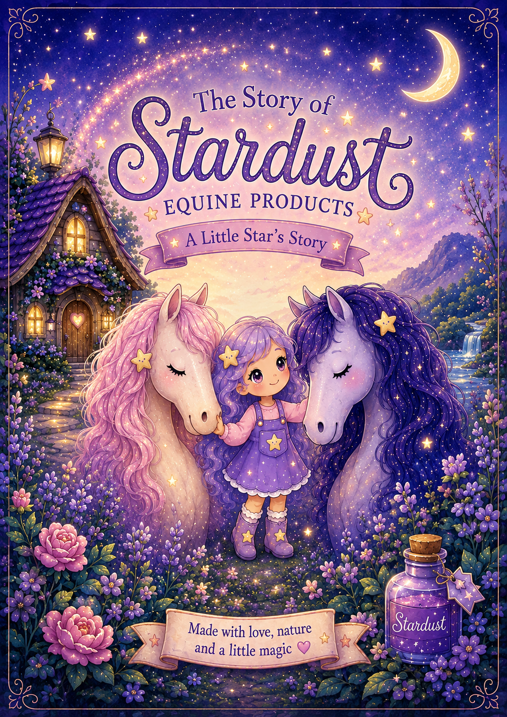

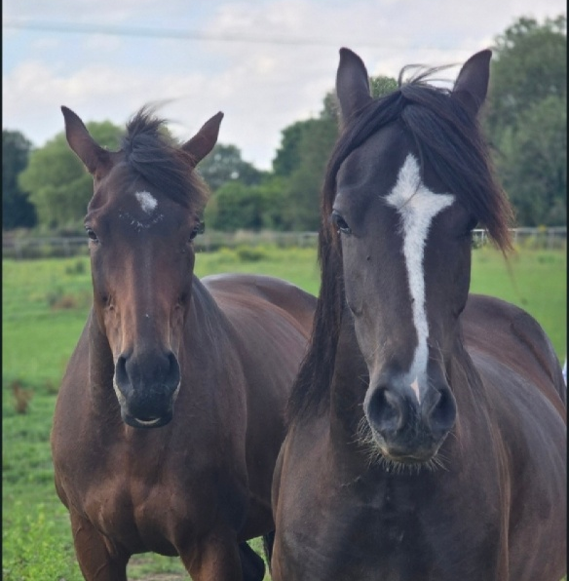

Welcome to Stardust
Every magical story begins with love.
Ours began with the horses and pony who filled our hearts with joy and taught us that the smallest acts of kindness can make the biggest difference.
Inspired by our own journey together, this little story celebrates friendship, nature and the special bond between horses and the people who love them.
We hope every page brings a smile, every adventure sparks your imagination, and every sprinkle of stardust reminds you that the greatest magic is found in gentle hands and kind hearts.
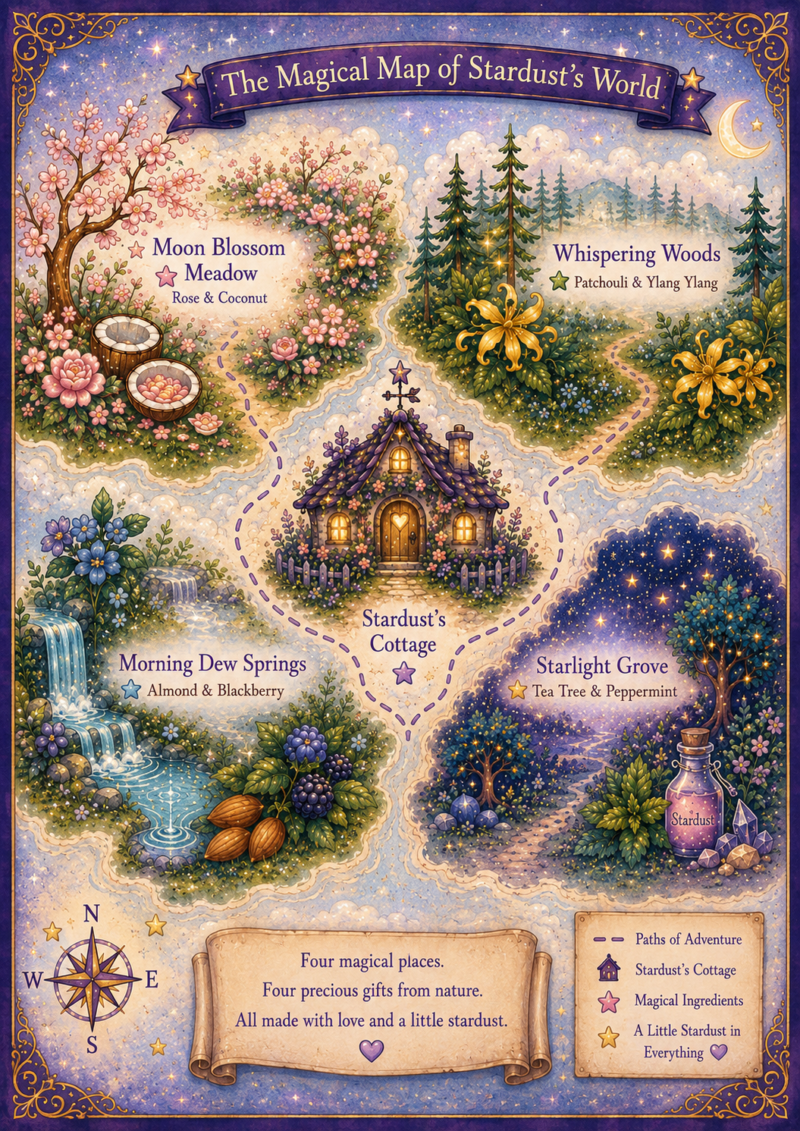

Once Upon a Starry Night...
High above the world, where the stars twinkled like tiny lanterns, there lived a little star girl named Stardust.
Oh, how she loved to watch the horses below.
She noticed that some on some days, raced through green fields.
There were some horses and ponies that carried children on wonderful adventures.
And some simply stood quietly beside the people they loved.

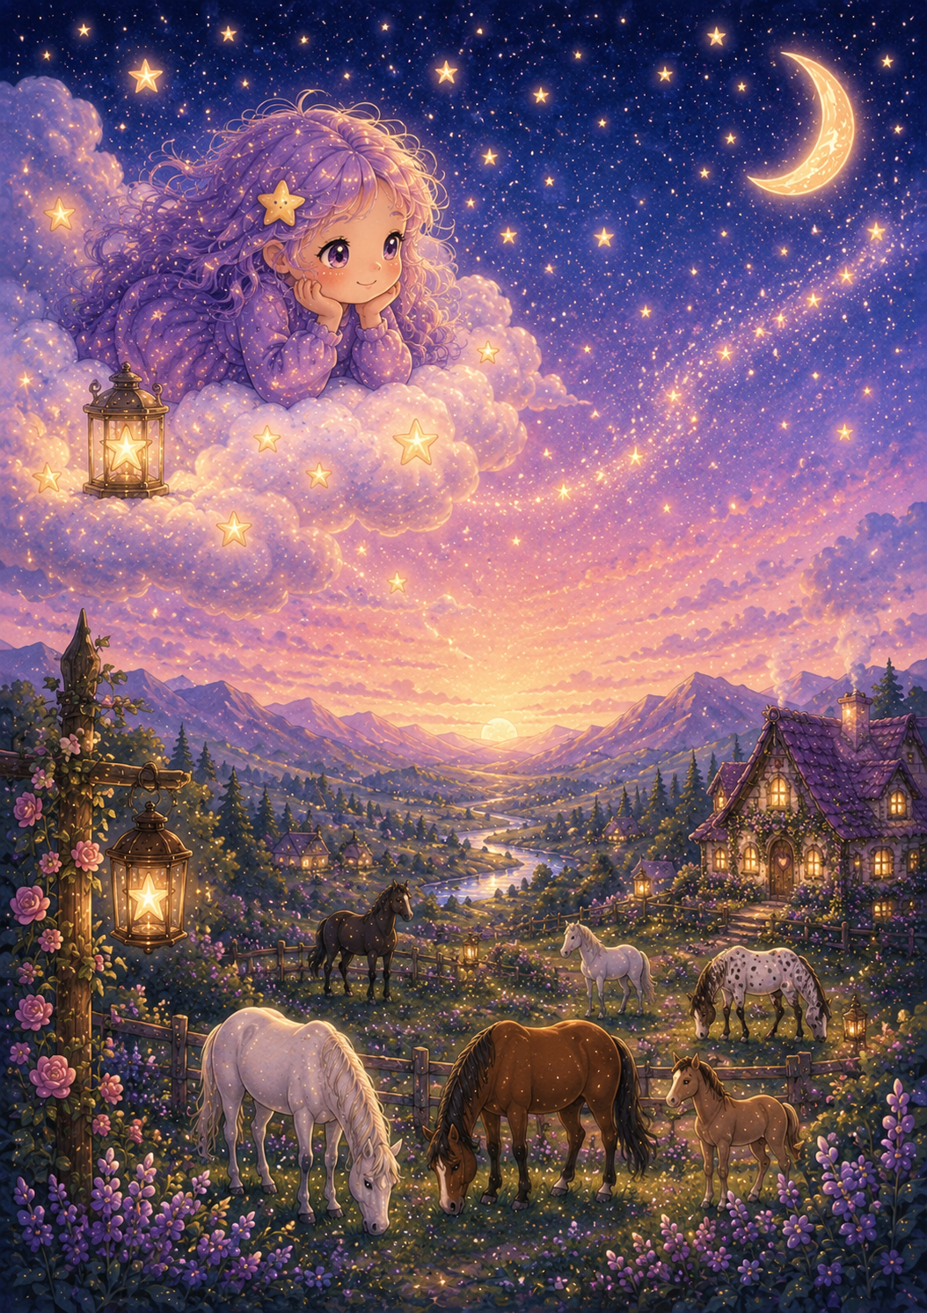

Every horse held a little light inside them.
And Stardust loved every single one.
One evening...
she noticed something else – something beyond what they did.
Some of the horses looked tired,
There were ponies that had tangled manes, dry coats after long winters.
Some of them even had sore little hooves after many adventures.
"I wish I could help them," she whispered to the stars.
The stars in the sky smiled...
and unknown to Stardust, her adventure was about to begin.

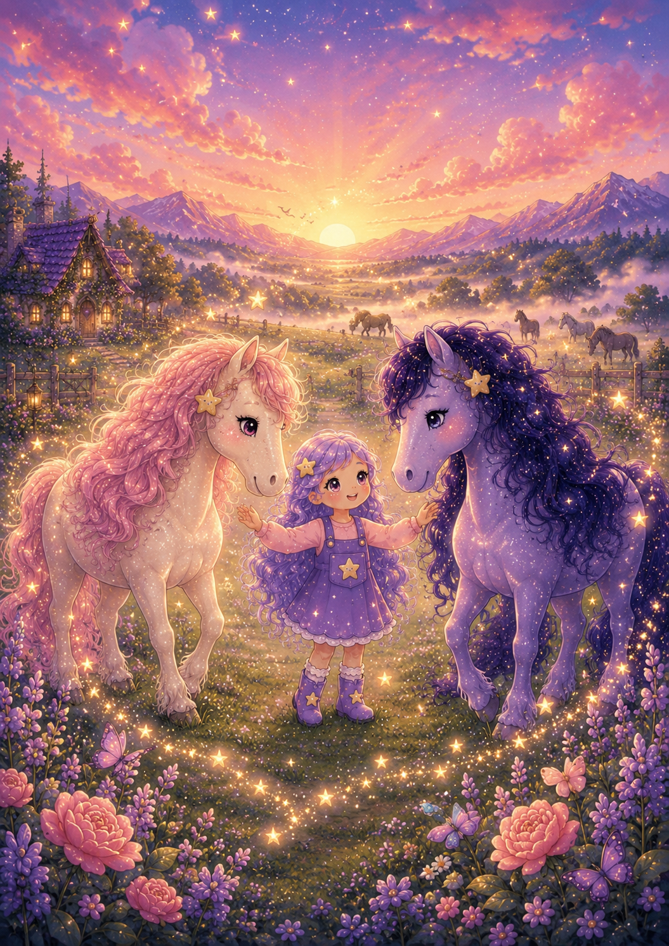

As her wish drifted through the night sky, a swirl of shimmer and sparkle appeared, and as it cleared, standing there were two magical horses, two New Friends to join her adventure and help her in her mission, you might call it.

One shimmered like moonlight and star dust.
"My name is Luna-Glimmer," she said with a gentle smile.
The other sparkled like a velvety night sky filled with stars.
"And I'm Shimmer-Nova," he said proudly.
"We've been waiting for you." -
Together, the three friends set off to discover nature's greatest treasures.

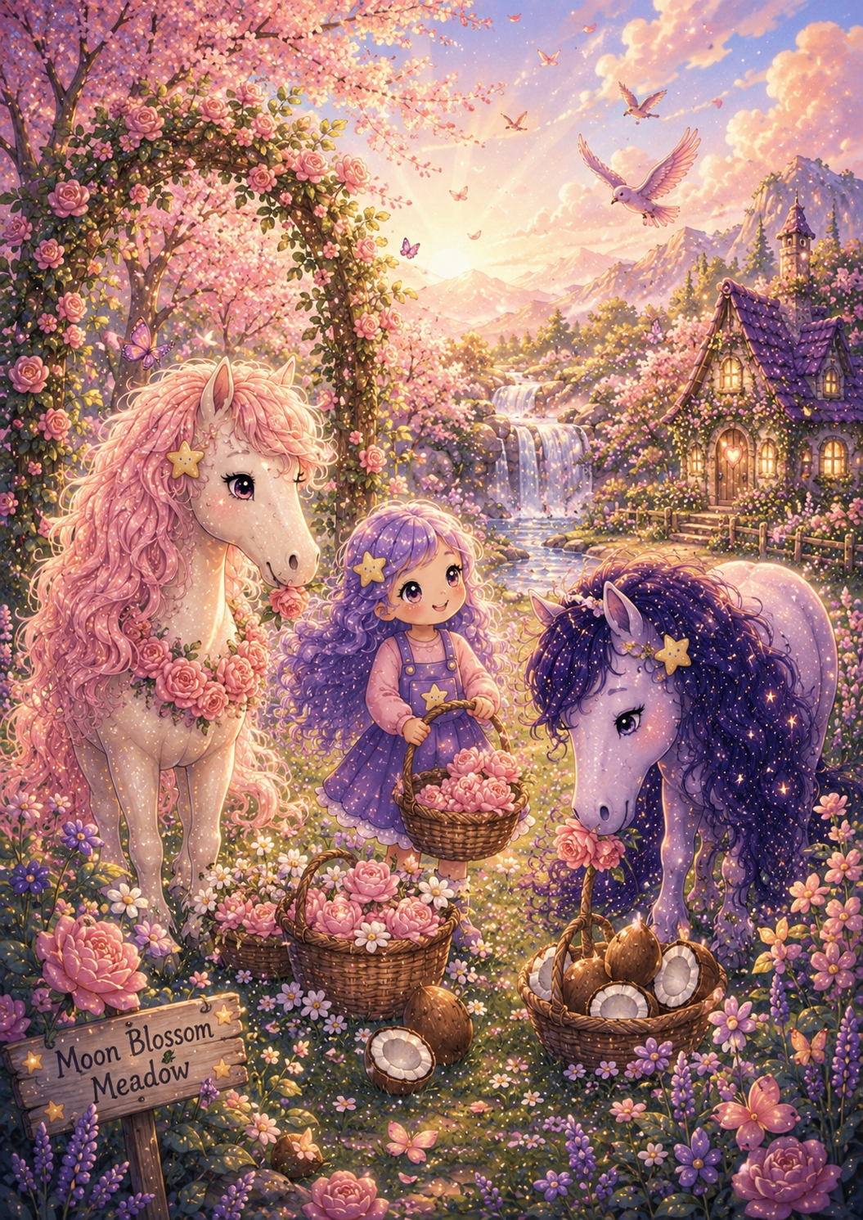

Moon Blossom Meadow

The air here smelled sweet like spring mornings.
Soft pink blossoms danced upon the breeze.
Each flower only opened when it felt completely safe.
Luna-Glimmer smiled.
"These are Moon Blossoms."
"Their petals remind every horse that gentle care always begins with kindness."
Nearby grew creamy white coconuts, warmed beneath the golden sunshine.
Together, they created the gentlest balm.
Perfect for soft manes.

Silky tails.
And quiet moments shared grooming between horse and human.
Stardust carefully gathered only what nature happily offered.
Never more.
And always with thanks.

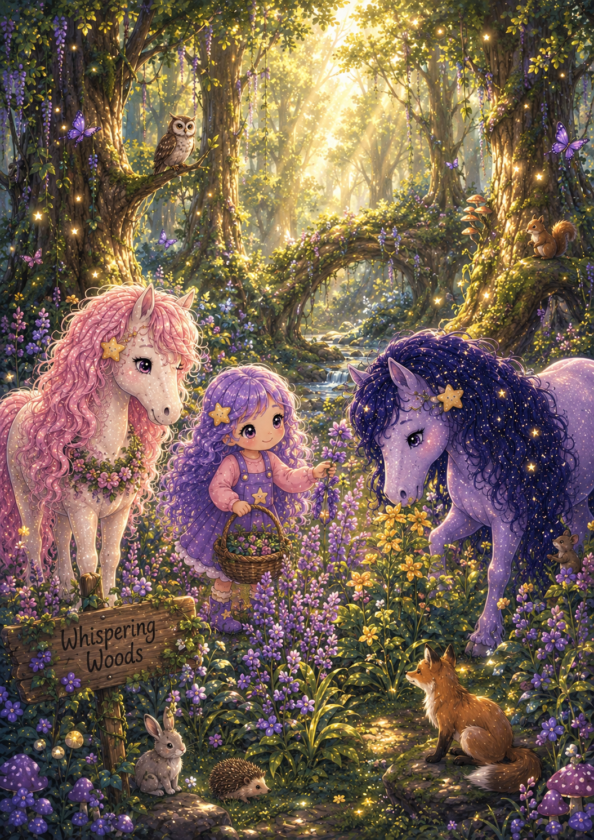

Whispering Woods

There were tall ancient trees that swayed gently overhead.
The leaves whispered stories carried by the wind.
Patchouli leaves grew beneath their roots.
Their earthy scent wrapped around everything like a comforting hug.
Nearby, golden Ylang Ylang blossoms filled the woodland with their delicate perfume.
Shimmer-Nova breathed deeply.
"This forest teaches us that calm and confidence can grow together."

Stardust blended the two gifts into a magical detangler potion.
Soon every tangled mane became easier to brush.
Not because of magic alone...
but because patient hands and gentle hearts always work best together.

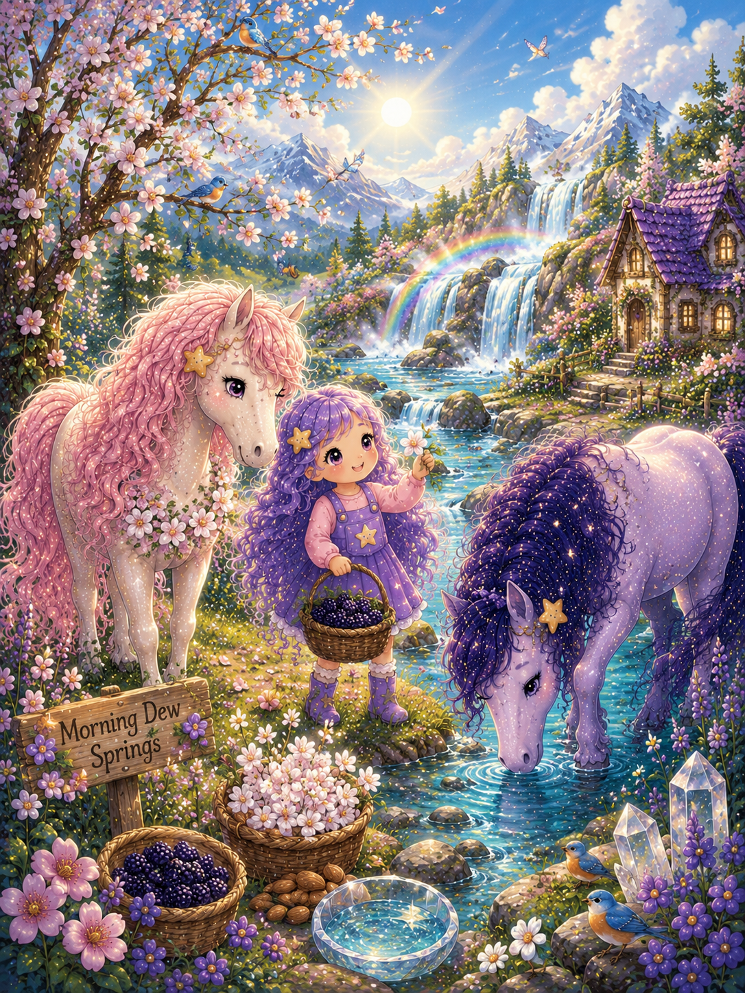

Morning Dew Springs
As dawn arrived, tiny pearls of dew sparkled across the meadow; it looked so pretty and sparkly.
There were big and beautiful Almond trees that stretched their branches into the morning sky.
Wild blackberry vines climbed happily beside them.
The clear spring water gathered every gentle ingredient into one shimmering pool.
Luna-Glimmer smiled, a gentle and soft smile.

"This place reminds us that every morning brings a fresh beginning."
Next, Stardust carefully bottled the sparkling water together with a touch of almond and just the right amount of blackberry.
It became the sweetest shampoo.
Soft bubbles.
Clean coats.
Happy horses.

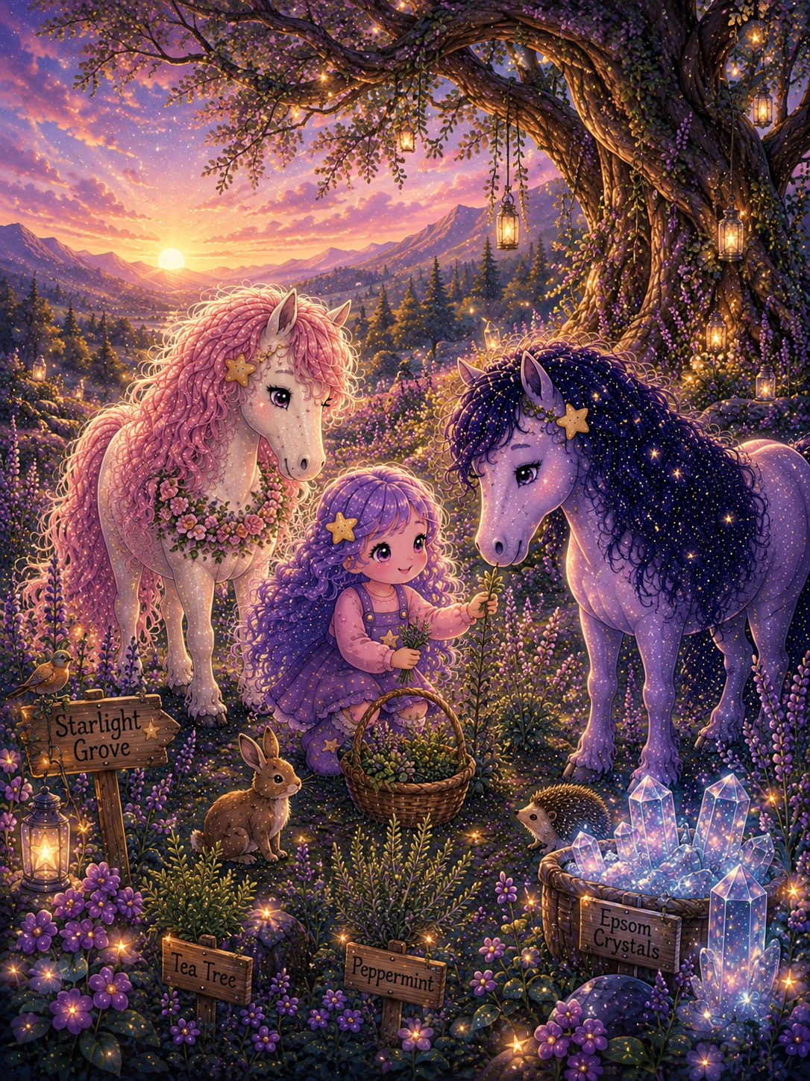

Starlight Grove
When evening arrived, the friends wandered into a quiet grove where the stars seemed close enough to touch, and magic was sprinkled all around .
Silver tea trees shimmered beneath the moon.
Peppermint leaves danced in the cool night breeze.
Hidden amongst the rocks were tiny sparkling Epsom crystals.
Shimmer-Nova smiled.
"This grove reminds us to rest after every adventure."

Together, they created a soothing hoof oil.
Gentle.
Cooling.
Kind.
Just what tired little hooves needed after long days exploring.

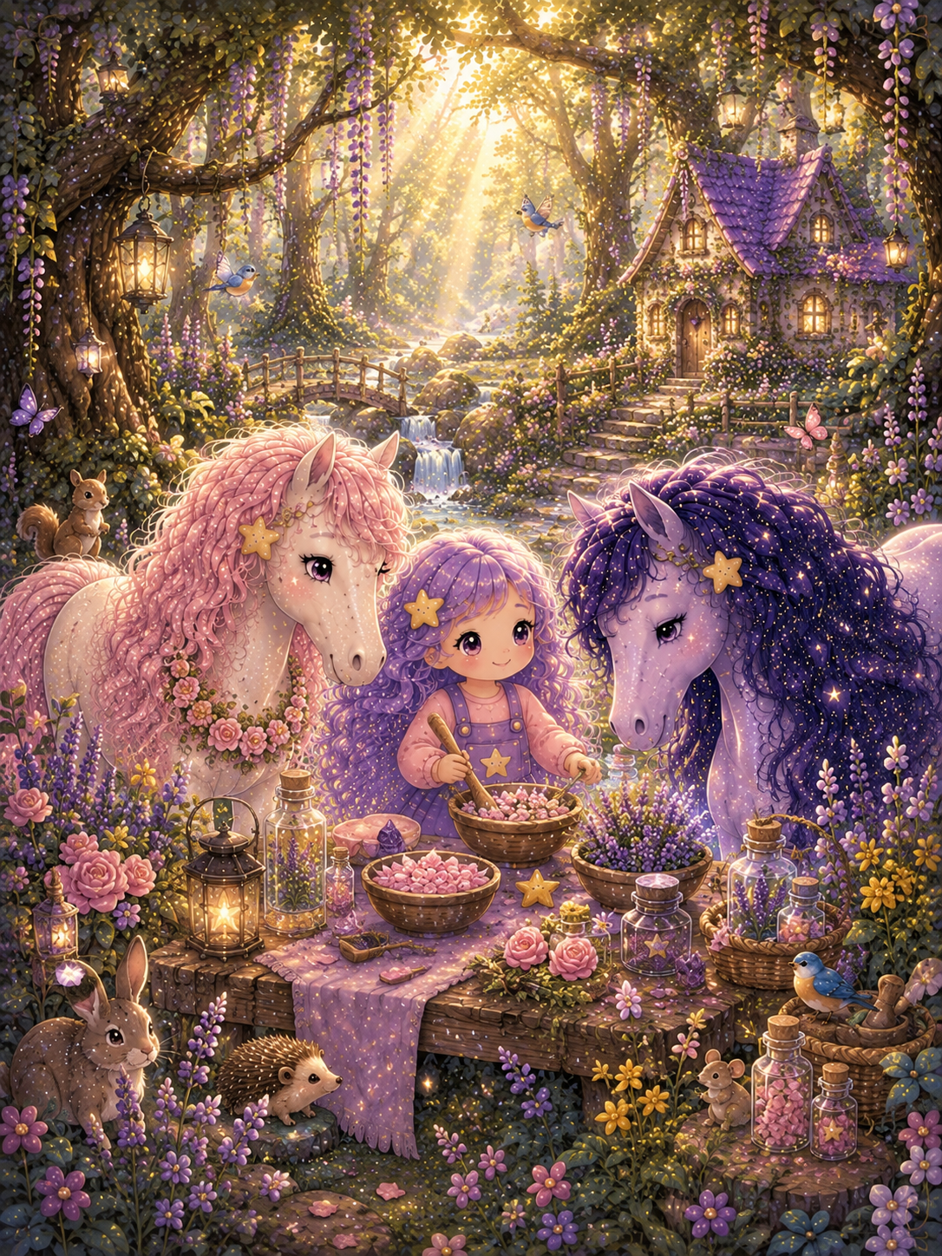

They finally arrived back at their cosy little cottage. Stardust looked proudly at the shelves.
Four beautiful bottles stood waiting.
Each one held a gift from nature.
Each one carried a sprinkle of stardust.
Each one had been made with love.

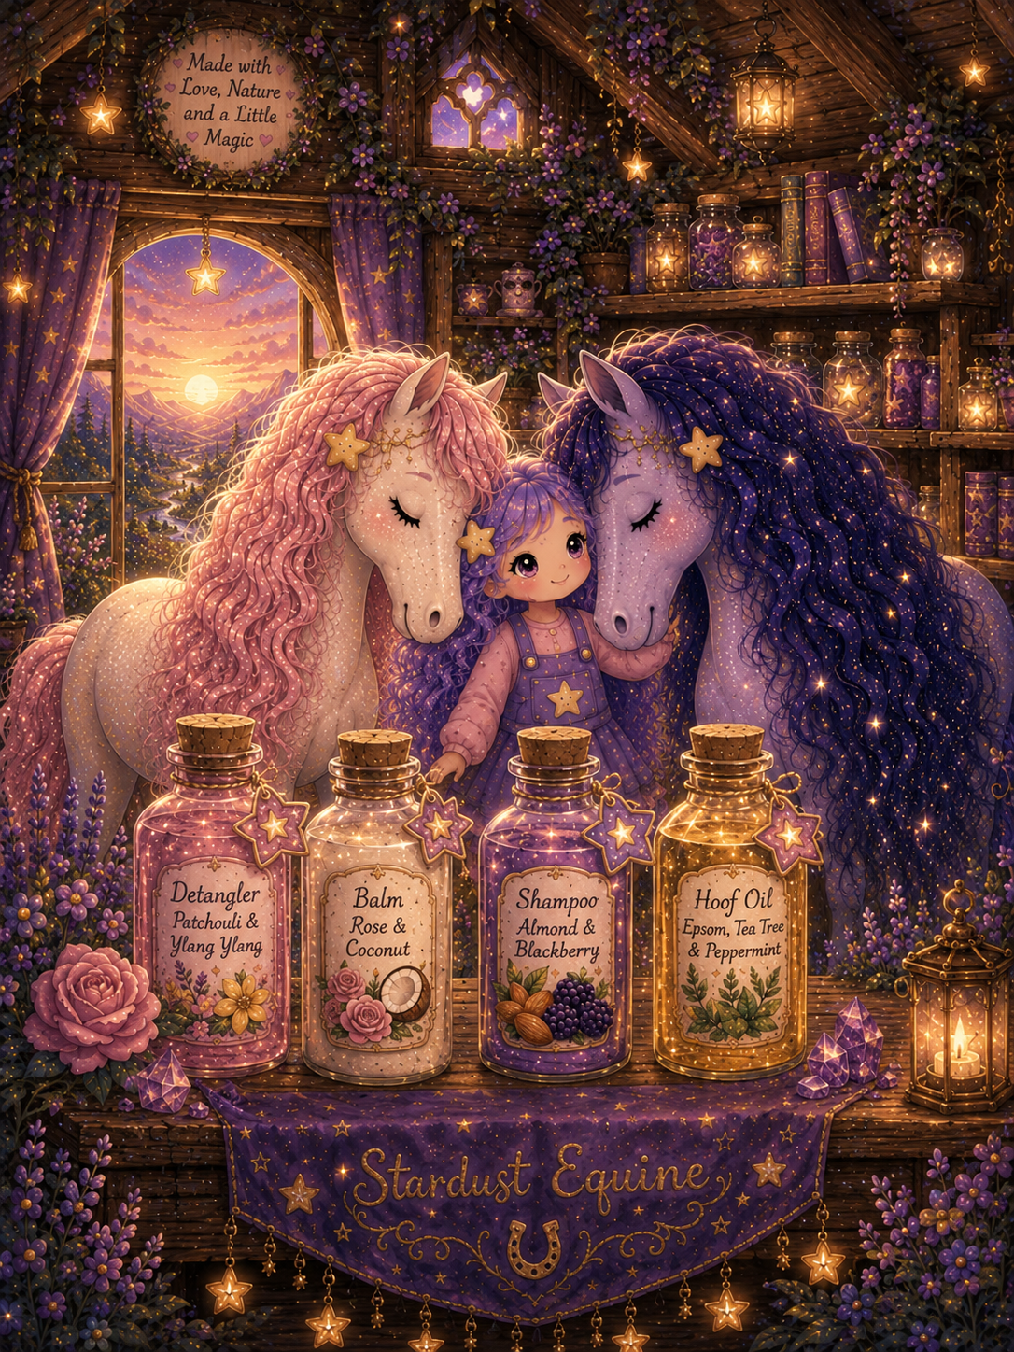

From that day on, horses everywhere were cared for with the treasures gathered from Moon Blossom Meadow, Whispering Woods, Morning Dew Springs, and Starlight Grove.
And whenever someone gently brushed a mane...
washed a muddy coat...
or rubbed soothing oil into tired little hooves...
Stardust smiled.
Not because of the bottles upon her shelves...
but because she knew the greatest magic had never been inside those bottles, not really,

The greatest magic had always been...
the gentle hands using them.
The quiet moments shared.
The trust that grew with every brushstroke.
The love between horse and human.

Another Adventure?
Stardust gently placed the final bottle onto the shelf and smiled.
Luna-Glimmer looked around the little cottage.
"We've travelled such a long way." – We should rest first.
Shimmer-Nova chuckled softly.
"I think this adventure is the first of many – let's rest before we start out again."
“yes rest first and then”, Stardust reached into her satchel and carefully unrolled an old shimmering map.
Tiny stars danced across the parchment as glowing pathways slowly appeared.
She smiled.

"There are still many places we haven't explored..."
Together they looked across the magical map.

Golden Oat Fields
Lavender Hollow
Honeybee Meadow
Silver Fern Forest
Rainbow Falls
Crystal Clover Hill

...and many more waiting to be discovered.
Luna-Glimmer smiled.
"I wonder what treasures we will find next."
Shimmer-Nova pawed the ground excitedly.
"I think another adventure is calling."
Stardust carefully rolled up the map and tucked it safely back into her satchel.
She turned towards the reader (that is you ) with a little twinkle in her eyes.
"Perhaps..."
"...next time..."
"...you'll come with us."

The Stardust Promise
Made with love, guided by nature, and finished with a little stardust.

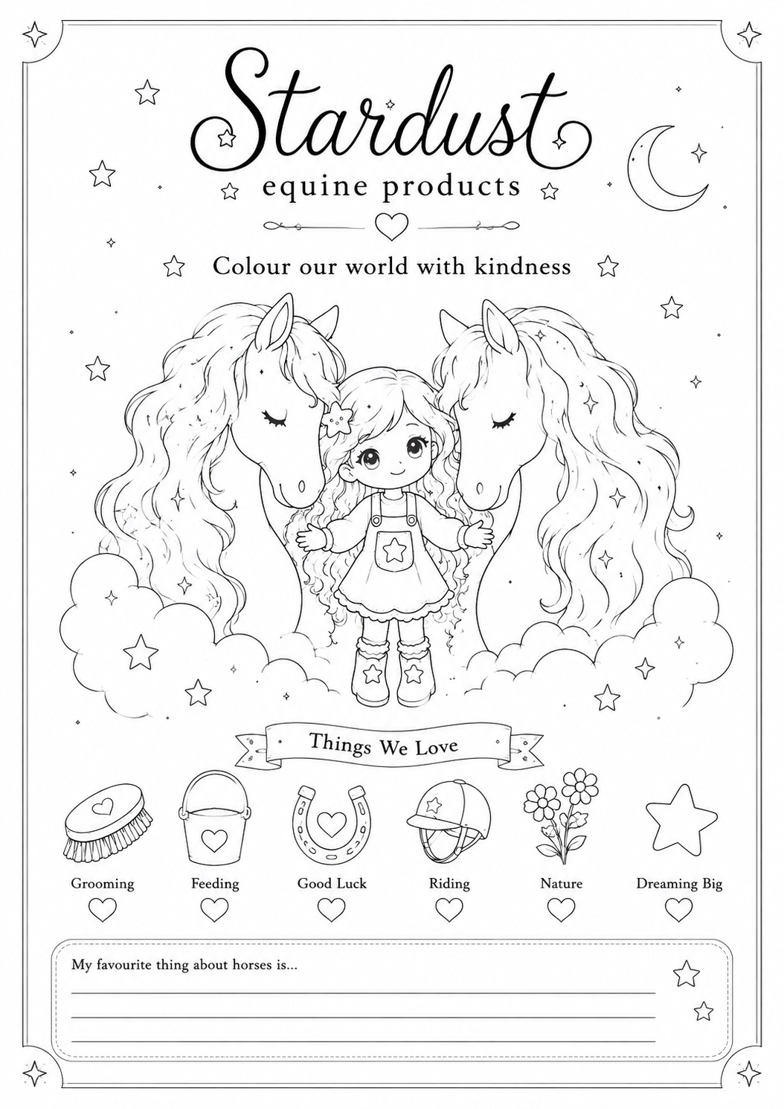

Copyright © 2025 Teresa Brown
Written by Teresa Brown
Illustrated by Saffire Brown & Teresa Brown
Published by Hatter Publishing Ltd
Company No. 16691257
All rights reserved. No part of this publication may be reproduced, stored,
or transmitted in any form or by any means without prior written permission
of the publisher.

